Social Worker Following Patient Smart Zone Alert
GO-LIVE July 20
The process will be followed for patients at Women & Children Hospital. In the future, this may be rolled out to other HHS Hospitals.
The goal is to alert the staff when Social Work is following a patient across admissions. A SmartZone alert will appear. Upon admission, it is important to notify the social worker that the patient is here and to follow any directions given in the social worker/case management notes.
Process: The social worker at W&C will chart on the PowerForm Social Worker Following. When a patient is being followed, the social worker will chart “Social Worker following patient”. When following is complete, the social worker will chart “Social Worker no longer following patient”. This charting, along with the patient location and patient type, will determine whether the smart zone alert appears.
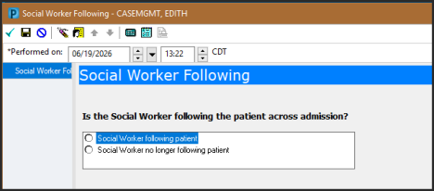The Smart Zone alert is an open chart alert and will display as follows:
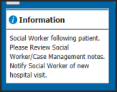
Staff who see this alert should contact their social workers upon a patient's admission or arrival. Then they should review the social worker/case management notes for updates.

